Civil war in Georgia

UNSC Resolution: | 1427
Date of adoption: | 07/29/02
Operative paragraph: | 6
Demand number: | 1427.0611

David Siroky

Wording of demand

receive the "Basic Principles for the Distribution of Competencies between Tbilisi and Sukhumi" and its transmittal letter

List of addressees of the demand

Government of Georgia, Abkhazia

Short-term compliance

Description of the addressee(s)’ conduct

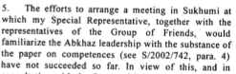

S/2002/1141

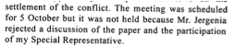

S/2002/1141

Assessment

Short-term compliance
No or marginal compliance (1) | Medium low compliance (2) | Medium high compliance (3) | Full or almost full compliance (4)

Considerations underlying the assessment

Medium-term compliance

Description of the addressee(s)’ conduct

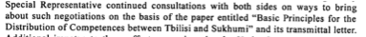
S/2003/39

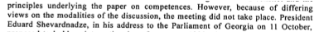
S/2003/39

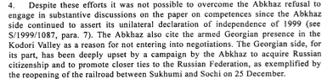
S/2003/39

Assessment

Medium-term compliance
No or marginal compliance (1) | Medium low compliance (2) | Medium high compliance (3) | Full or almost full compliance (4)

Considerations underlying the assessment

Depth of demand

Assessment

Level of depth of demand
Low depth of demand (1) | Medium depth of demand (2) | High depth of demand (3)

Considerations underlying the assessment

Level of confidence about coding decisions

Level of confidence about coding decision
Extremely high | High | Moderate

Comments to IPI (if any)

Civil war in Georgia

UNSC Resolution: | 1427
Date of adoption: | 07/29/02
Operative paragraph: | 6
Demand number: | 1427.0612

David Siroky

Wording of demand

give "Basic Principles for the Distribution of Competencies between Tbilisi and Sukhumi" full and open consideration and engage in constructive negotiations on their substance

List of addressees of the demand

Government of Georgia, Abkhazia

Short-term compliance

Description of the addressee(s)’ conduct

S/2002/1141

S/2002/1141

Assessment

Short-term compliance
No or marginal compliance (1) | Medium low compliance (2) | Medium high compliance (3) | Full or almost full compliance (4)

Considerations underlying the assessment

Medium-term compliance

Description of the addressee(s)’ conduct

S/2003/39

S/2003/39

S/2003/39

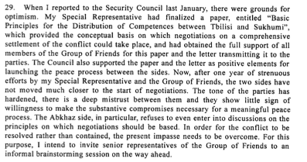

S/2003/39

Assessment

Medium-term compliance
No or marginal compliance (1) | Medium low compliance (2) | Medium high compliance (3) | Full or almost full compliance (4)

Considerations underlying the assessment

Depth of demand

Assessment

Level of depth of demand
Low depth of demand (1) | Medium depth of demand (2) | High depth of demand (3)

Considerations underlying the assessment

Level of confidence about coding decisions

Level of confidence about coding decision
Extremely high | High | Moderate

Comments to IPI (if any)

Civil war in Georgia

UNSC Resolution: | 1427
Date of adoption: | 07/29/02
Operative paragraph: | 7
Demand number: | 1427.0711

David Siroky

Wording of demand

spare no efforts to overcome ongoing mutual mistrust of the other party

List of addressees of the demand

Government of Georgia, Abkhazia

Short-term compliance

Description of the addressee(s)’ conduct

S/2002/1141

S/2002/1141

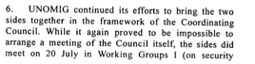
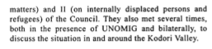

S/2002/1141

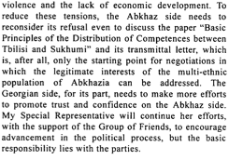

S/2002/1141

Assessment

Short-term compliance
No or marginal compliance (1) | Medium low compliance (2) | Medium high compliance (3) | Full or almost full compliance (4)

Considerations underlying the assessment

Medium-term compliance

Description of the addressee(s)’ conduct

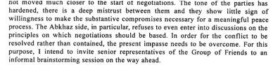
S/2003/39

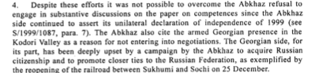
S/2003/39

Assessment

Medium-term compliance
No or marginal compliance (1) | Medium low compliance (2) | Medium high compliance (3) | Full or almost full compliance (4)

Considerations underlying the assessment

Depth of demand

Assessment

Level of depth of demand
Low depth of demand (1) | Medium depth of demand (2) | High depth of demand (3)

Considerations underlying the assessment

Level of confidence about coding decisions

Level of confidence about coding decision
Extremely high | High | Moderate

Comments to IPI (if any)

Civil war in Georgia

UNSC Resolution: | 1427
Date of adoption: | 07/29/02
Operative paragraph: | 8
Demand number: | 1427.0811

David Siroky

Wording of demand

cease violations of the Moscow Agreement (S/1994/583, annex I) immediately

List of addressees of the demand

Government of Georgia, Abkhazia

Short-term compliance

Description of the addressee(s)’ conduct

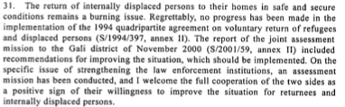
S/2003/39

Assessment

Short-term compliance
No or marginal compliance (1) | Medium low compliance (2) | Medium high compliance (3) | Full or almost full compliance (4)

Considerations underlying the assessment

Medium-term compliance

Description of the addressee(s)’ conduct

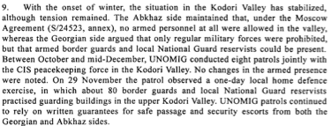
S/2003/39

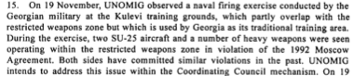

S/2003/39

Assessment

Medium-term compliance
No or marginal compliance (1) | Medium low compliance (2) | Medium high compliance (3) | Full or almost full compliance (4)

Considerations underlying the assessment

Depth of demand

Assessment

Level of depth of demand
Low depth of demand (1) | Medium depth of demand (2) | High depth of demand (3)

Considerations underlying the assessment

Level of confidence about coding decisions

Level of confidence about coding decision
Extremely high | High | Moderate

Comments to IPI (if any)

Civil war in Georgia

UNSC Resolution: | 1427
Date of adoption: | 07/29/02
Operative paragraph: | 10
Demand number: | 1427.1011

David Siroky

Wording of demand

continue to improve security for joint UNOMIG and CIS peacekeeping force patrols in the Kodori Valley to enable them to monitor the situation independently and regularly

List of addressees of the demand

Government of Georgia, Abkhazia

Short-term compliance

Description of the addressee(s)’ conduct

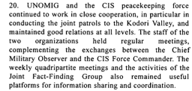

S/2002/1141

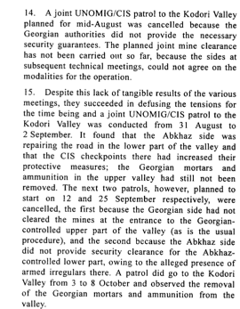

S/2002/1141

Assessment

Short-term compliance
No or marginal compliance (1) | Medium low compliance (2) | Medium high compliance (3) | Full or almost full compliance (4)

Considerations underlying the assessment

Medium-term compliance

Description of the addressee(s)’ conduct

S/2003/39

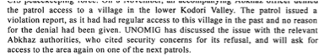
S/2003/39
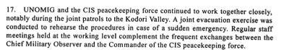
S/2003/39

Assessment

Medium-term compliance
No or marginal compliance (1) | Medium low compliance (2) | Medium high compliance (3) | Full or almost full compliance (4)

Considerations underlying the assessment

Depth of demand

Assessment

Level of depth of demand
Low depth of demand (1) | Medium depth of demand (2) | High depth of demand (3)

Considerations underlying the assessment

Level of confidence about coding decisions

Level of confidence about coding decision
Extremely high | High | Moderate

Comments to IPI (if any)

Civil war in Georgia

UNSC Resolution: | 1427
Date of adoption: | 07/29/02
Operative paragraph: | 11
Demand number: | 1427.1111

David Siroky

Wording of demand

ensure the necessary revitalization of the peace process in all its major aspects, to resume work in the Coordinating council and its relevant mechanisms, to build on the results of the Yalta meeting on confidence-building measures, and to implement the proposals agreed on that occasion in a purposeful and cooperative manner

List of addressees of the demand

Government of Georgia, Abkhazia

Short-term compliance

Description of the addressee(s)’ conduct

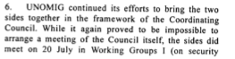
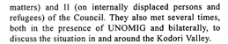

S/2002/1141

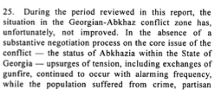

S/2002/1141

Assessment

Short-term compliance
No or marginal compliance (1) | Medium low compliance (2) | Medium high compliance (3) | Full or almost full compliance (4)

Considerations underlying the assessment

Medium-term compliance

Description of the addressee(s)’ conduct

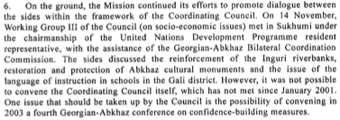

S/2003/39

Assessment

Medium-term compliance
No or marginal compliance (1) | Medium low compliance (2) | Medium high compliance (3) | Full or almost full compliance (4)

Considerations underlying the assessment

Depth of demand

Assessment

Level of depth of demand
Low depth of demand (1) | Medium depth of demand (2) | High depth of demand (3)

Considerations underlying the assessment

Level of confidence about coding decisions

Level of confidence about coding decision
Extremely high | High | Moderate

Comments to IPI (if any)

Civil war in Georgia

UNSC Resolution: | 1427
Date of adoption: | 07/29/02
Operative paragraph: | 13
Demand number: | 1427.1311

David Siroky

Wording of demand

implement the recommendations of the joint assessment mission to the Gali district, carried out under the aegis of the UN

List of addressees of the demand

Government of Georgia, Abkhazia

Short-term compliance

Description of the addressee(s)’ conduct

S/2002/1141

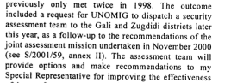

S/2002/1141

Assessment

Short-term compliance
No or marginal compliance (1) | Medium low compliance (2) | Medium high compliance (3) | Full or almost full compliance (4)

Considerations underlying the assessment

Medium-term compliance

Description of the addressee(s)’ conduct

S/2003/39

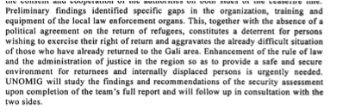

S/2003/39

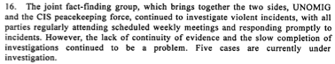

S/2003/39

Assessment

Medium-term compliance
No or marginal compliance (1) | Medium low compliance (2) | Medium high compliance (3) | Full or almost full compliance (4)

Considerations underlying the assessment

Depth of demand

Assessment

Level of depth of demand
Low depth of demand (1) | Medium depth of demand (2) | High depth of demand (3)

Considerations underlying the assessment

Level of confidence about coding decisions

Level of confidence about coding decision
Extremely high | High | Moderate

Comments to IPI (if any)

Civil war in Georgia

UNSC Resolution: | 1427
Date of adoption: | 07/29/02
Operative paragraph: | 13
Demand number: | 1427.1312

David Siroky

Wording of demand

improve law enforcement involving the local population and address the lack of instruction in Georgian of the local Georgian population

List of addressees of the demand

Abkhazia

Short-term compliance

Description of the addressee(s)’ conduct

S/2002/1141

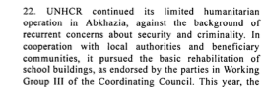

S/2002/1141

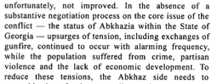
S/2002/1141

Assessment

Short-term compliance
No or marginal compliance (1) | Medium low compliance (2) | Medium high compliance (3) | Full or almost full compliance (4)

Considerations underlying the assessment

Medium-term compliance

Description of the addressee(s)’ conduct

S/2003/39

Assessment

Medium-term compliance
No or marginal compliance (1) | Medium low compliance (2) | Medium high compliance (3) | Full or almost full compliance (4)

Considerations underlying the assessment

Depth of demand

Assessment

Level of depth of demand
Low depth of demand (1) | Medium depth of demand (2) | High depth of demand (3)

Considerations underlying the assessment

Level of confidence about coding decisions

Level of confidence about coding decision
Extremely high | High | Moderate

Comments to IPI (if any)

Civil war in Georgia

UNSC Resolution: | 1427
Date of adoption: | 07/29/02
Operative paragraph: | 14
Demand number: | 1427.1411

David Siroky

Wording of demand

publicly dissociate from militant rhetoric and demonstrations of support for military operations and for the activities of illegal armed groups

List of addressees of the demand

Government of Georgia, Abkhazia

Short-term compliance

Description of the addressee(s)’ conduct

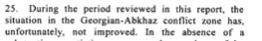

S/2002/1141

S/2002/1141

Assessment

Short-term compliance
No or marginal compliance (1) | Medium low compliance (2) | Medium high compliance (3) | Full or almost full compliance (4)

Considerations underlying the assessment

Medium-term compliance

Description of the addressee(s)’ conduct

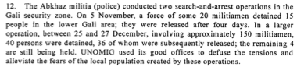

S/2003/39

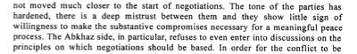
S/2003/39

Assessment

Medium-term compliance
No or marginal compliance (1) | Medium low compliance (2) | Medium high compliance (3) | Full or almost full compliance (4)

Considerations underlying the assessment

Depth of demand

Assessment

Level of depth of demand
Low depth of demand (1) | Medium depth of demand (2) | High depth of demand (3)

Considerations underlying the assessment

Level of confidence about coding decisions

Level of confidence about coding decision
Extremely high | High | Moderate

Comments to IPI (if any)

Civil war in Georgia

UNSC Resolution: | 1427
Date of adoption: | 07/29/02
Operative paragraph: | 14
Demand number: | 1427.1412

David Siroky

Wording of demand

uphold commitment to end the activities of illegal armed groups

List of addressees of the demand

Government of Georgia, Abkhazia

Short-term compliance

Description of the addressee(s)’ conduct

S/2002/1141

S/2002/1141

Assessment

Short-term compliance
No or marginal compliance (1) | Medium low compliance (2) | Medium high compliance (3) | Full or almost full compliance (4)

Considerations underlying the assessment

Medium-term compliance

Description of the addressee(s)’ conduct

S/2003/39

S/2003/39

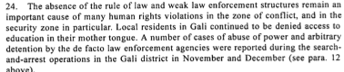

S/2003/39

Assessment

Medium-term compliance
No or marginal compliance (1) | Medium low compliance (2) | Medium high compliance (3) | Full or almost full compliance (4)

Considerations underlying the assessment

Depth of demand

Assessment

Level of depth of demand
Low depth of demand (1) | Medium depth of demand (2) | High depth of demand (3)

Considerations underlying the assessment

Level of confidence about coding decisions

Level of confidence about coding decision
Extremely high | High | Moderate

Comments to IPI (if any)

Civil war in Georgia

UNSC Resolution: | 1427
Date of adoption: | 07/29/02
Operative paragraph: | 15
Demand number: | 1427.1511

David Siroky

Wording of demand

take all necessary steps to identify those responsible for the shooting down of a UNOMIG helicopter on 8 October 2001 and bring them to justice as well as provide appropriate security and ensure the freedom of movement of UNOMIG, the CIS peacekeeping force and other international personnel

List of addressees of the demand

Government of Georgia, Abkhazia

Short-term compliance

Description of the addressee(s)’ conduct

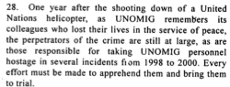

S/2002/1141

Assessment

Short-term compliance
No or marginal compliance (1) | Medium low compliance (2) | Medium high compliance (3) | Full or almost full compliance (4)

Considerations underlying the assessment

Medium-term compliance

Description of the addressee(s)’ conduct

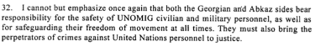

S/2003/39

Assessment

Medium-term compliance
No or marginal compliance (1) | Medium low compliance (2) | Medium high compliance (3) | Full or almost full compliance (4)

Considerations underlying the assessment

Depth of demand

Assessment

Level of depth of demand
Low depth of demand (1) | Medium depth of demand (2) | High depth of demand (3)

Considerations underlying the assessment

Level of confidence about coding decisions

Level of confidence about coding decision
Extremely high | High | Moderate

Comments to IPI (if any)

